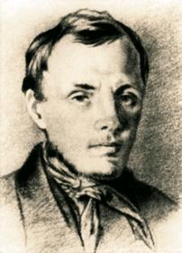 | RUS2102  The Age of Dostoevsky and Tolstoy  Jan. – Apr. 2010  Monday 11:30-13:00  Thursday 13:00-14:30  Simard 222 | 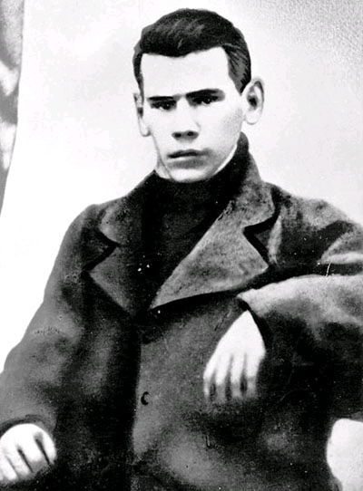

Professor: Douglas Clayton
Tel.: 613-562-5800, ext. 3765
Office: Arts Hall 108
Office hours: Monday 2:00 - 4:00 p.m.
Email: Douglas.Clayton@uottawa.ca;
Home page: http://aix1.uottawa.ca/~jdclayt/main_e_welcome.htm

This course focuses on the literature of Russia’s Golden Age of prose. The writers Fyodor Dostoevsky and Lev Tolstoy will be examined as part of the ongoing tradition of Russian literature and against the literary, cultural and philosophical currents of their time. At the end of the course students will have a grasp of the basic issues surrounding some of the greatest works of Russian and world literature.

ASSIGNMENTS AND GRADES

A. Midterm (20%)
The midterm will be based on a list of questions distributed in advance. There will be some identification questions, plus one essay question.
Date of mid-term: February 25th.
B. Written papers (2 x 20%)
Students will submit two papers of 6-8 pages (approx. 2,000 words) each, analyzing material from the first and second parts of the course (i.e., before and after the mid-term) respectively. Each paper will be an analysis of a theme, motif, character, or chosen passage from one of the works studied.
Due dates: February 11th and March 25th
C. Final exam (30%)
The final will be based on a list of questions distributed in advance. It will comprise some identification questions, plus two essay questions.
D. Participation (10%)
Students will submit brief written comments or questions on the material under discussion in class. There may also be occasional “pop-quizzes”; these will demonstrate both students’ familiarity with the material and involvement in the work of the course.
E. Attendance Policy
Attendance will not be taken since presence in the classroom is not a proof of participation. Students are expected to have actively prepared the material being discussed and to be ready to contribute to the in-class discussions. Any student who has, in the estimation of the professor, insufficiently contributed to the course may be excluded from the final exam in accordance with faculty regulations.
REQUIRED READINGS
Course Pack (on sale at the Laurier Office Mart, 226, Laurier Ave. East.)
Aleksandr Pushkin, “The Queen of Spades.”
Nikolai Gogol, “The Overcoat.”
Fyodor Dostoevsky, “Dream of a Ridiculous Man.”
Vsevolod Garshin, “Four Days.”
Anton Chekhov, “Peasants,” “The Student.”

b) In University Bookstore
Ivan Turgenev, First Love and Other Stories. Oxford World’s Classics. ISBN
978-0-19-954040-2
Fyodor Dostoevsky, Crime and Punishment. Penguin Classics. ISBN 978-0-140-44913-6
Lev Tolstoy, Childhood. Tark Classic Fiction. ISBN 978-1604501490
Lev Tolstoy, Anna Karenina. Penguin Classics. ISBN 978-0-140-44917-4

SYLLABUS
07.01 Russia under Nicholas  11.01 From Romanticism to Realism:  Pushkin's “Queen of Spades”  14.01 Gogol: “The Overcoat.”  18.01 Turgenev: “First Love.”  21.01 Oblomov and oblomovitis.  25.01 Alexander and the age of reform. The Nihilists.  28.01 Dostoevsky: his life and meaning.  01.02 Crime and Punishment.  04.02 Crime and Punishment.  08.02 Crime and Punishment.  11.02 Crime and Punishment.  22.02 “Dream of a Ridiculous Man”  25.02 Midterm | 01.03 Tolstoy: life and meaning.  04.03 Tolstoy: Childhood.  08.03 Tolstoy: Childhood.  11.03 War and Peace: extracts.  15.03 Anna Karenina  18.03 Anna Karenina  22.03 Anna Karenina  25.03 Anna Karenina  29.03 Anna Karenina  01.04 After 1881: the reaction, the new reader Garshin: “Four Days.”  08.04 Chekhov: “Peasants.”  12.04 Chekhov: “The Student.”

For an up-to-date syllabus, bibliography and other information, visit the course webpage at:

http://aix1.uottawa.ca/~jdclayt/RUS2102_welcome.htm

